Theory:
Descriptive statistics provide a summary of the dataset using numerical measures. These include mean, median, standard deviation, minimum, and maximum values. Mean represents the average value of a dataset. Median indicates the central value and is less affected by outliers. Standard deviation measures data spread or variability. Minimum and maximum values show the range of data. For categorical data, mode and frequency counts are used. These statistics help in understanding the distribution and patterns in data. They provide insights before applying advanced techniques. This step is essential for initial data exploration.
Dataset Description:
The dataset includes numerical columns such as Open, High, Low, Close, and Volume. These columns represent daily trading values. The data is continuous and suitable for statistical analysis. No categorical variables are significantly present.
Program Code:
import pandas as pd
import numpy as np

# Step 2: Load Dataset
df = pd.read_csv('silver_prices_data.csv')

print("\n===== DATASET LOADED ====")
print(df.head())

# --------------------------------------------
# Step 3: Separate Numerical & Categorical Columns
# --------------------------------------------
numerical_cols = df.select_dtypes(include=[np.number]).columns
categorical_cols = df.select_dtypes(include=['object']).columns

print("\nNumerical Columns:", list(numerical_cols))
print("Categorical Columns:", list(categorical_cols))

# --------------------------------------------
# Step 4: Descriptive Statistics for Numerical Columns
# --------------------------------------------
print("\n===== NUMERICAL STATISTICS ====")

num_stats = pd.DataFrame({
"Mean": df[numerical_cols].mean(),
"Median": df[numerical_cols].median(),
"Std Dev": df[numerical_cols].std(),
"Min": df[numerical_cols].min(),
"Max": df[numerical_cols].max()
})

print(num_stats)

# --------------------------------------------
# Step 5: Descriptive Statistics for Categorical Columns
# --------------------------------------------
print("\n===== CATEGORICAL STATISTICS ====")

cat_summary = []

for col in categorical_cols:
mode_val = df[col].mode()[0]
value_counts = df[col].value_counts().head(5) # top 5

cat_summary.append({
"Column": col,
"Mode": mode_val,
"Top Values": str(value_counts.to_dict())
})

cat_stats = pd.DataFrame(cat_summary)

print(cat_stats)

# --------------------------------------------
# Step 6: Observations (Auto-generated)
# --------------------------------------------
print("\n===== INITIAL OBSERVATIONS ====")

for col in numerical_cols:
print(f"\n🔹 Column: {col}")
print(f"Mean: {df[col].mean():.2f}")
print(f"Median: {df[col].median():.2f}")
print(f"Min: {df[col].min():.2f}")
print(f"Max: {df[col].max():.2f}")

if df[col].mean() > df[col].median():
print("→ Slight right skew (possible high-value outliers)")
elif df[col].mean() < df[col].median():
print("→ Slight left skew")
else:
print("→ Symmetric distribution")

# --------------------------------------------
# Step 7: Save Results
# --------------------------------------------
num_stats.to_csv("numerical_statistics.csv")
cat_stats.to_csv("categorical_statistics.csv")

print("\nFiles saved: numerical_statistics.csv & categorical_statistics.csv")

Stepwise output:
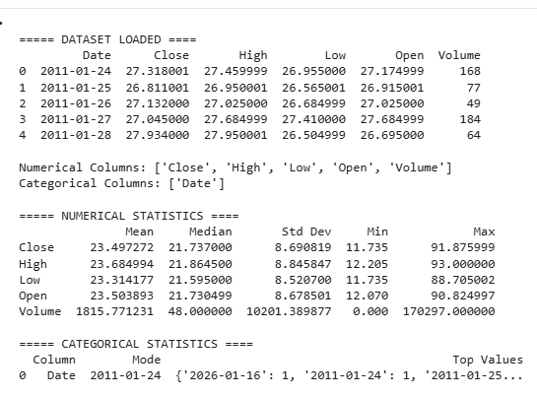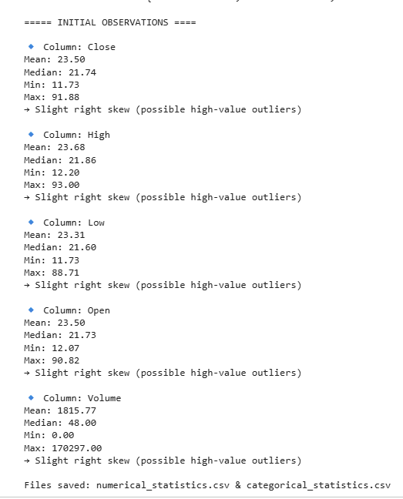Conclusion:
Descriptive statistics reveal the central tendency and variability of silver prices. The dataset shows moderate fluctuations over time. No abnormal patterns were observed. It provides a strong base for further analysis.

